Name: | ___________________________________________________ |  | Date: ___________
 | Year 12 Essentials Mathematics  Test 4, 2017  Topic –Pythagoras’ Theorem and Trigonometry |  | 50  = %
Total Time: | 60 minutes
Total Reading: | 5 minutes
Total Working: | 55 minutes
Weighting: | ______% of the year.
Equipment: | ½ page notes (A4 one side), Scientific Calculator

1. | [2 marks: 1, 1]
 | Label the sides Hypotenuse, Opposite and Adjacent on the following right angled triangles:
 | 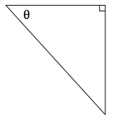 | 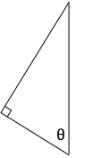

2. | [2 marks: 1, 1]
 | Label the angle in the correct place on the following right angled triangles:
a) | 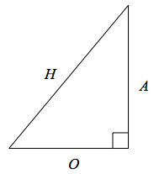 | 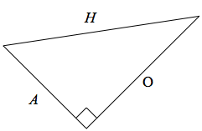

3. | [9 marks, 3, 3, 3 ]
 | Determine the value of the pronumeral in each of the following
 |  | 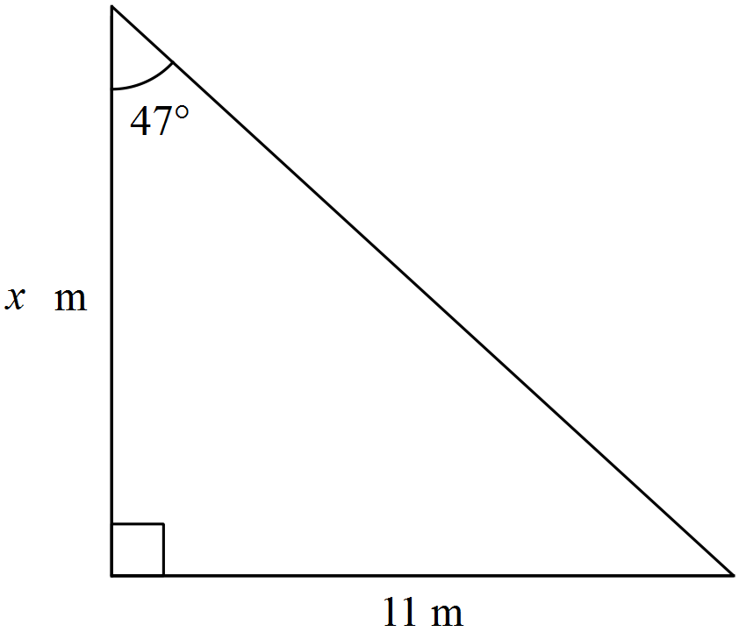

4. | [4 marks ]
 | A boy notices a bird sitting at the very top of a 10m tall tree. If he is standing 8m from the base of the tree, what is the distance between his eye and the top of the tree?

5. | [4 marks ]
 | A 25 m flagpole casts a 42 m shadow. What is the angle the sun makes with the flagpole
 | 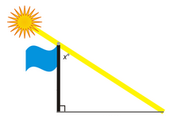

6. | [9 marks, 3, 3, 3 ]
 | Determine the value of the pronumeral in each of the following
 | 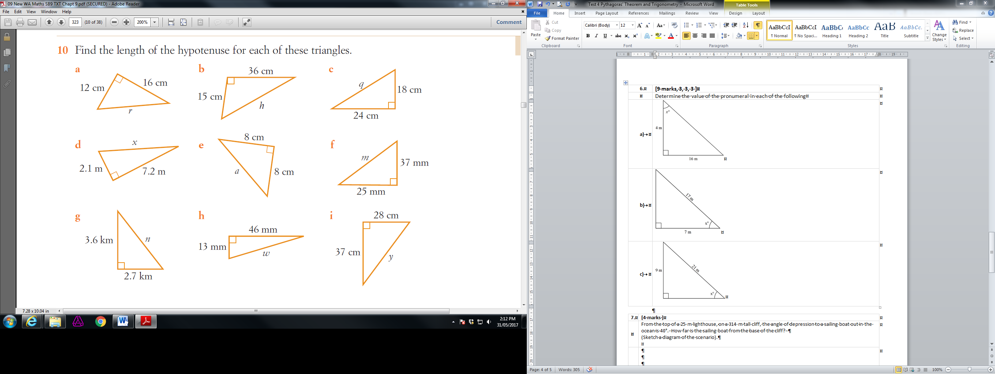
 | 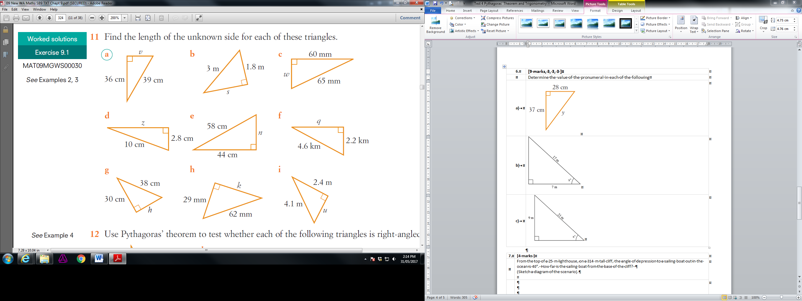
 | 

7. | [4 marks ]
From the top of a 25 m lighthouse, on a 314 m tall cliff, the angle of depression to a sailing boat out in the ocean is 40°. How far is the sailing boat from the base of the cliff?
(Sketch a diagram of the scenario).

8. | [6 marks ]
 | From an observer at O who is 200m from a building, the angles of elevation to the bottom and top of a flagpole are 36º and 38 º respectively. Find the height of the flagpole.
 | 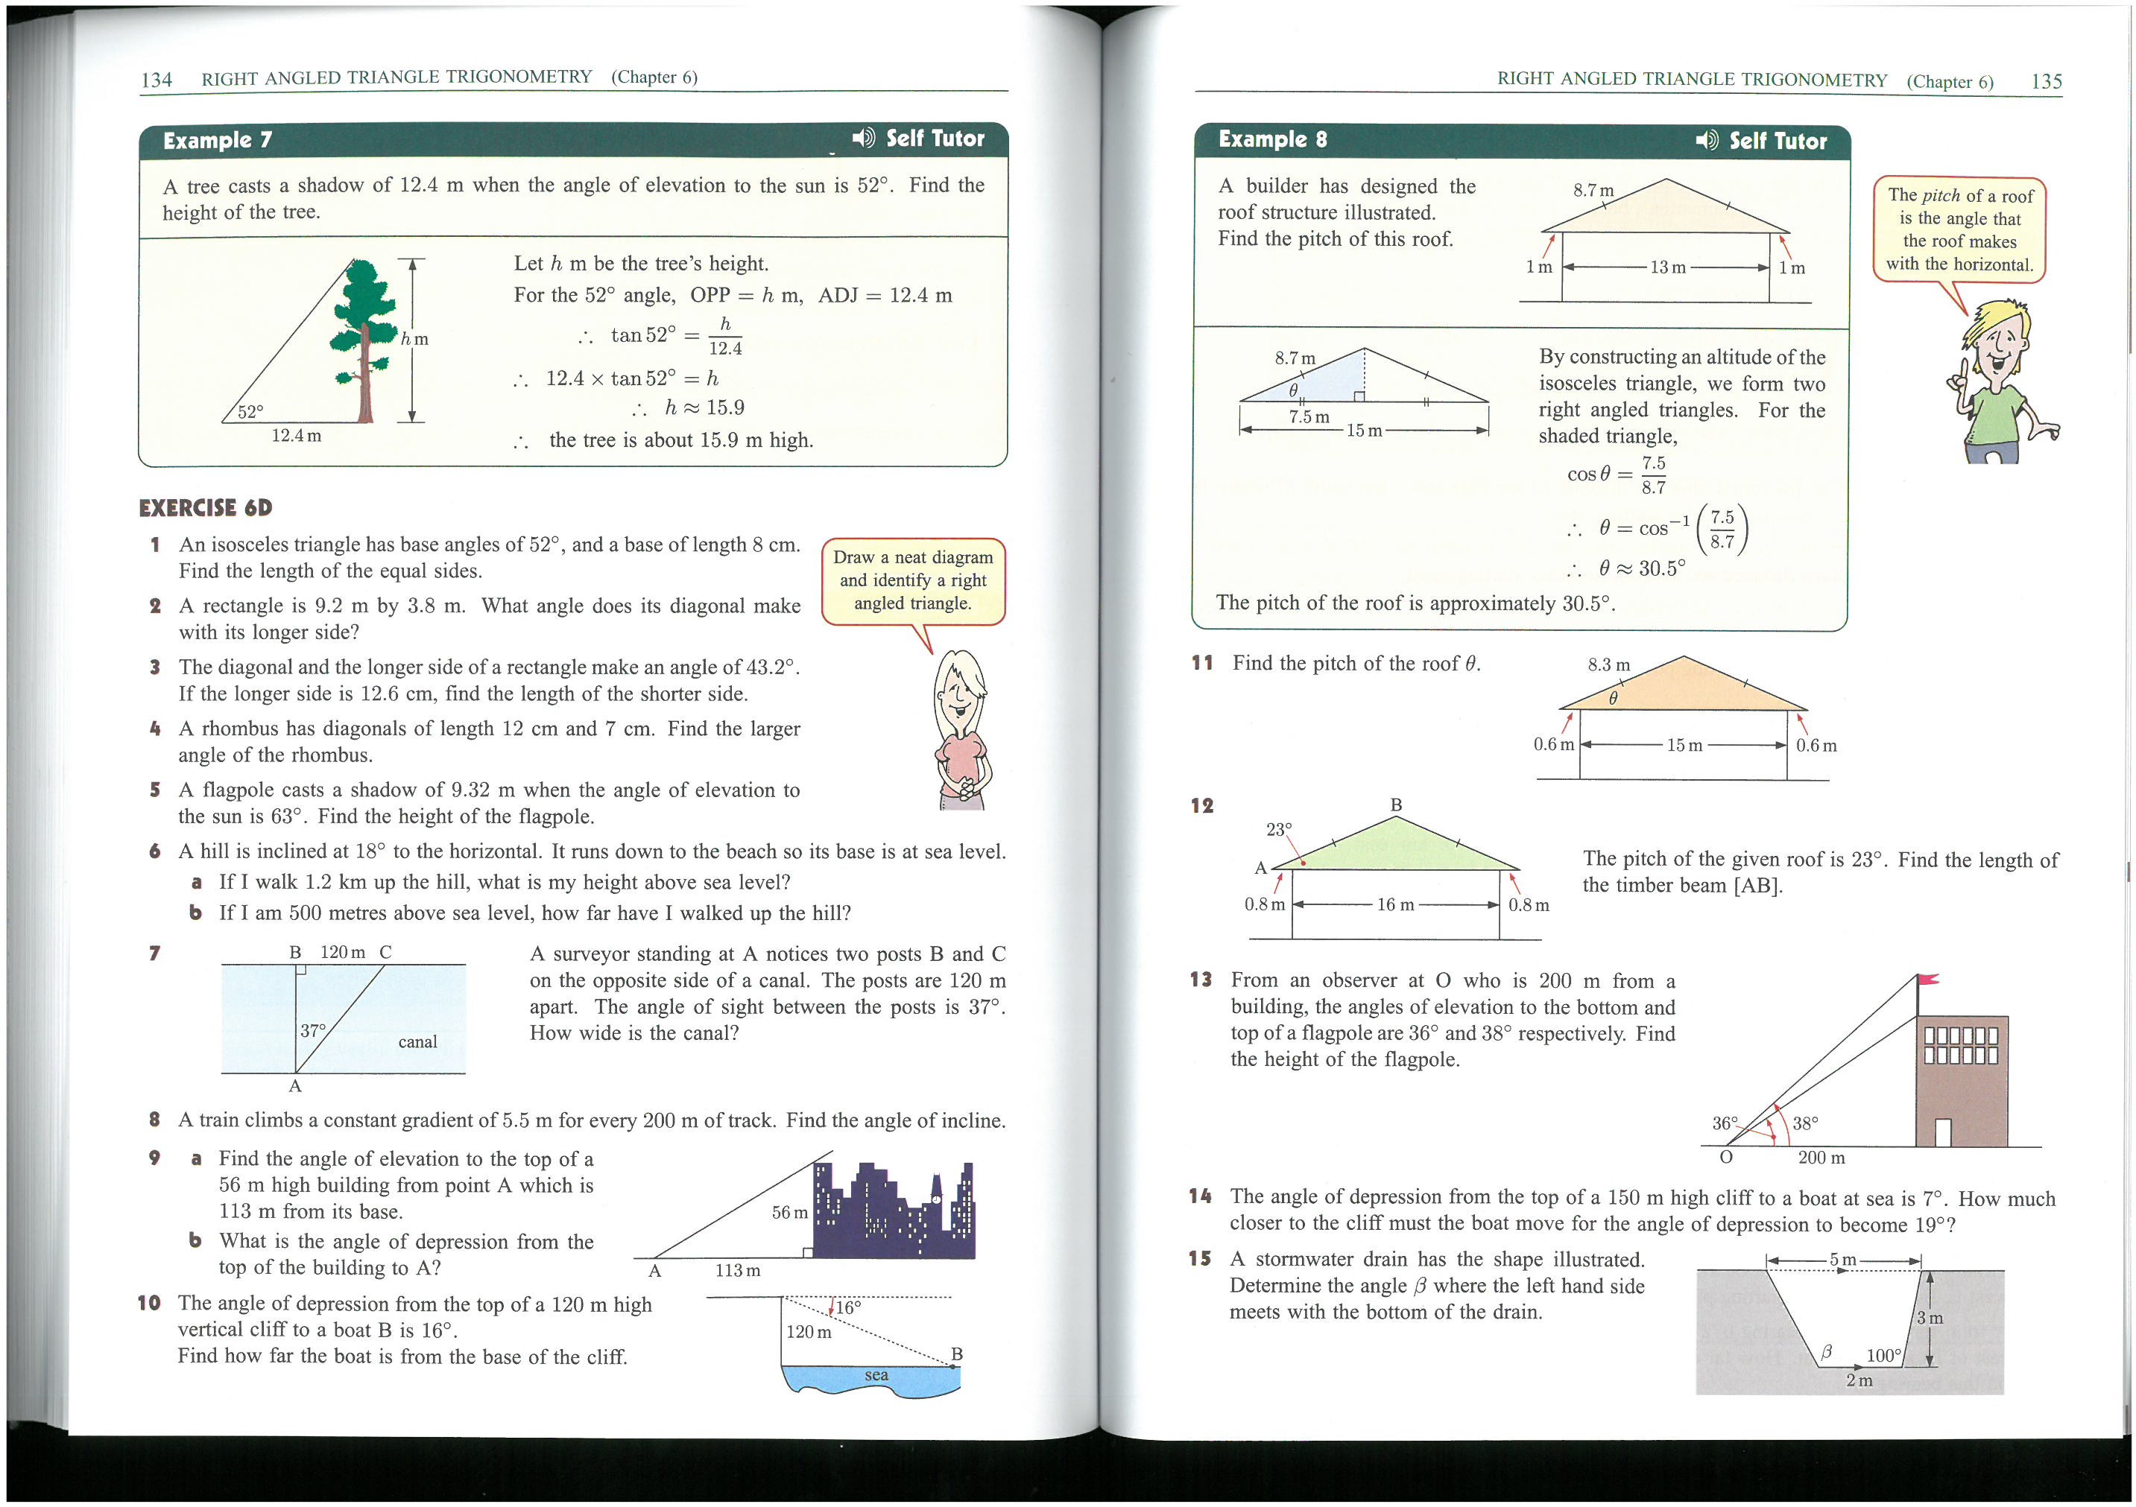

9. | [4 marks ]
The school council needs to have a ramp build over the steps of each of the building exits, to accommodate a student in a wheelchair. If the junior school building is 35cm off the ground and has steps that reach out 50cm, calculate the length of the ramp
(Sketch a diagram of the scenario).

10. | [6 marks ]
Ashley hikes 17km on a bearing of 134º.
a. Draw a diagram of the situation
b. How far east is Ashley from his starting point?
c. How far south is Ashley from his starting point?

~ END OF TEST ~

